Here is a compiled list of all OLL and PLL cases that use the optimal move count under the half-turn-metric system (HTM).

OLL

Most cases and images are according to <http://www.speedsolving.com/wiki/index.php/OLL> with assistance in converting notation using <http://alg.garron.us/?cube=3x3x3&stage=OLL>. Some images have been rotated in order to program them into CSRubik’s easier. The numbering system is universal throughout both sites.

**All edges flipped correctly, anchor on position 3 if facing up**

1. 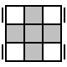 R U R' U R U' R' U R U2 R'
2. 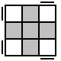 R U2 R2' U' R2 U' R2' U2 R
3. 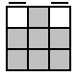 R2 D' R U2 R' D R U2 R
4. 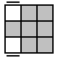 B L F’ L’ B’ L F L’
5. 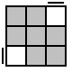 F’ L’ B’ L F L’ B L
6. 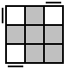 L U2 L’ U’ L U’ L’
7. 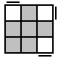 R U R’ U R U2 R’

**No edges flipped correctly, anchor on position 3 if facing up**

1. 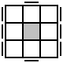R U2 R2 F R F’ U2 R’ F R F’
2. 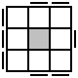F R' F' R U R2 B' R' B U' R'
3. 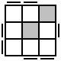 L’ R2 B R’ B L U2 L’ B R’ L
4. 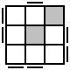B’ F R’ B U2 B’ R’ F R’ F2 B

17. 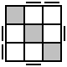 L’ F U2 B’ R U2 R’ B U2 F’ L

18. 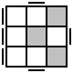 F R U R’ U F’ U2 F’ L F L’

19. 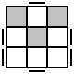R’ L F’ R’ F’ R F L’ R2 B’ R’ B

1. 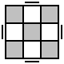R B U B' R' F2 B D' L' D B' F2

**“L” Shapes, L is always horizontally flipped**

1. 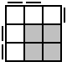R’ F2 L F L’ F R
2. 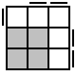 F R2 B’ R’ B R’ F’
3. 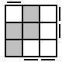L F R’ F R F2 L’
4. 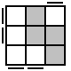B’ R’ F R’ F’ R2 B
5. 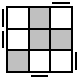R’ U’ R F R’ F’ U F R F’
6. 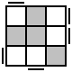 F U F’ R’ F R U’ R’ F’ R
7. 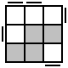L F R’ F R’ D R D’ R F2 L’
8. 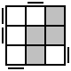 L F U F2 L F L2 U L U2 L’
9. 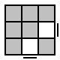L F R’ F’ L’ R U R U’ R’
10. 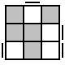 R’ F’ R B’ R’ F2 R’ F’ R2 B
11. 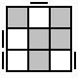F U R U’ B R’ F’ R B’ R’
12. 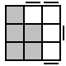 B’ U’ R U B U’ B’ R’ B
13. 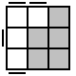 L U F’ U’ L’ U L F L’
14. 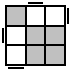L U2 L2 B L B’ L U2 L’
15. 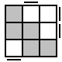F U F’ U’ L’ U2 L U F U F’
16. 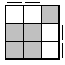F R’ F’ R U R U’ R’
17. 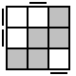 R’ U’ R U B U2 B’ U’ R’ U’ R
18. 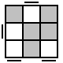 L R2 D’ F’ D F R F’ L’ R
19. 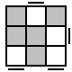B’ F2 D R D’ R’ F’ R F’ B
20. 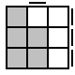 R’ U’ F’ U F R
21. 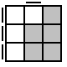 F U R U’ R’ F’
22. 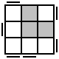 R’ F’ U’ F U F’ U’ F U R
23. 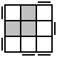 F R U R’ U’ R U R’ U’ F’
24. 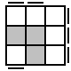 F R’ F2 L F2 R F2 L’ F
25. 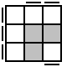R’ F R2 B’ R2 F’ R2 B R’
26. 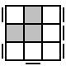 R’ F’ L F’ L’ F L F’ L’ F2 R
27. 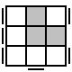 L F2 R’ F’ R F R’ F’ R F’ L’

**Line shapes, always horizontal**

1. 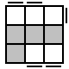 F U R U2 R' U' R U R' F'
2. 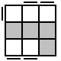 R’ F R U R’ F’ R F U’ F’
3. 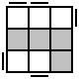L’ B’ L R’ U’ R U L’ B L
4. 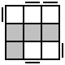 R B R’ L U L’ U’ R B’ R’
5. 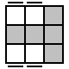L U L’ U’ L’ B L B’
6. 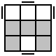R U R’ U’ B’ R’ F R F’ B
7. 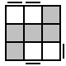 L F' L' U' L U F U' L'
8. 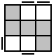 R' F R U R' U' F' U R
9. 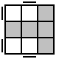F U R U’ R’ F’
10. 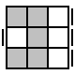 B’ U’ B’ R B R’ U B
11. 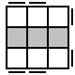F U R U’ R’ U R U’ R’ F’
12. 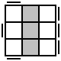 F’ U’ F U’ F’ U L’ U L F
13. 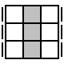 F U' R2 D R' U2 R D' R2' U F'
14. 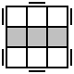F R U R’ U’ R F’ L F R’ F’ L’
15. 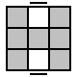R’ U’ R U R L’ B’ R’ B L

Optimal PLL HTM

All cases are from <http://cube.garron.us/algs/optimalPLL/>

1. 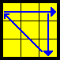B2 R2 B' L' B R2 B' L B'

2. 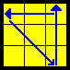B L' B R2 B' L B R2 B2

3.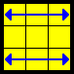L U' R D 2 R' U L' R U' L D 2 L' U R'

4. 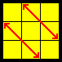B2 F2 U' L2 R2 D L R' D2 U2 L R'

5. 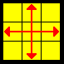L2 B2 F2 R2 D L2 B2 F2 R2

6. 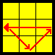F2 U' L R' F2 L' R U' F2

7. 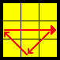F2 U L R' F2 L' R U F2

Place with good corner and good edge in position 0 and 8 (good for 7/10 cases) rest use 1 and 8

8. 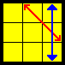 L2 B' U' B L2 F' D F' D' F2

9. 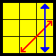 R2 B U B' R2 F D' F D F2

10. 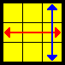R2 U' R2 D B2 L2 U L2 D' B2

11. 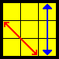 F' U2 F U2 F' L F U F' U' F' L' F2

12. 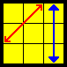 F U2 B F' U B' R' F U2 F2 U' F R

13. 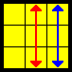 R L' B2 R D' L B2 R' U R' L2 F2 L2

18. 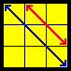 R U D2 L' U L U2 F2 D R D' F2 D2 R'

19. 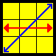 R2 F2 U2 F2 U F2 R2 U2 R2 U F2 U2 R2

20. 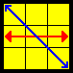 F2 R2 U2 R2 U' R2 F2 U2 F2 U' R2 U2 F2

21. 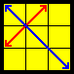R2 U R2 U R2 U' B' U' B R2 B' U B

14. 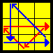 R2 B2 F2 U' F2 U F2 D' F2 D B2 R2

15. 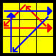 L2 B2 D F2 D' F2 U F2 U' F2 B2 L2

16. 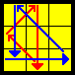 L2 B2 F2 U F2 U' F2 D F2 D' B2 L2

17. 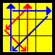 R2 B2 D' F2 D F2 U' F2 U F2 B2 R2